Minutes of the Committee Meeting 1st February 2016

Present: Nathan Scott Chairman
Andy Reid Secretary
Chris Green Treasurer
Dave Debnam Vice President
Paul Davies Men’s Captain
Andy Ward
Ashley Philpott
Thom Darby
Zena Ellis
Miriam Linforth

1 Chairman’s Comments
None

2 Apologies
Apologies were received from Lorraine Webb, who is unable to attend the meeting today.

3 Previous Minutes
No minutes were taken for January when the meeting dealt with the allocation of the awards for 2015.

4 Matters Arising

The venue has been booked for the awards evening at Crawley Green social club, on the 26th March. There will not be a separate Social evening in March.
Transport to the National Cross Country Finals at Donington, and the Manchester Marathon, need to be decided. The Secretary will investigate the costs of coaches and report back to the Chairman.
Three tickets have been sold so far for the Awards Evening.
The Catering for the evening is to be supplied by Cheryl McLaren.

5 Secretary Report
Sports tours advert for 2016
Haverhill Triathalon advert
The Peterborough Greenway Relays 19/06/16
Cancer Care Cross Bay Half Marathon
Great Birmingham Run
The Ouse Valley Marathon on 04/09/16
A Sports Therapist offering services
Ed Prickett Memorial Road Relays in Nottingham
A.Maidwell Smith asked to be a temporary member
A movement skills workshop in Watford in February
Level 2 coaching course in March 2016
England Athletics now sending monthly notification of athletes applying to change club

6 Treasurer’s Report
CG reports
The Accounts.

Bank: £7535.84p
Cash in hand: £241.06p
Cash in hand with Monday’s subs: £320.06p

During February, notable transactions and expenditure:
Charity: £747.59p

7 Running Report by Lorraine Webb & Paul Davies for February 2016
Running Report by Lorraine Webb & Paul Davies for January 2016
Welcome back everyone. I hope you had a good Christmas & New Year and didn’t put on too many unwanted extra seasonal pounds ! If you did, lace up your running shoes, get back out there and pound those pavements. Unfortunately, the dark nights are with us for a little while longer, so can we remind you to please wear hi-viz clothing wherever possible and try and avoid running in the dark in black. There are also some great flashing gadgets available on the web, so be safe, be seen.
Long Weekend 1st, 2nd & 3rd January
A busy weekend for Striders started on a cold, frosty New Year’s Day morning with 17 Striders running the Luton parkrun. Ben Bodsworth started 2016 as he finished 2015 with another pb, this time, finishing in 20:14. Mark Layzell also achieved a pb of 29:13 – well done guys, awesome running ! 10 Striders chose to run the parkrun double. 6 headed to St Albans, 3 headed further afield to a slippery & very muddy Tring and Liz Davies accompanied Stewart Read to Rushmere.
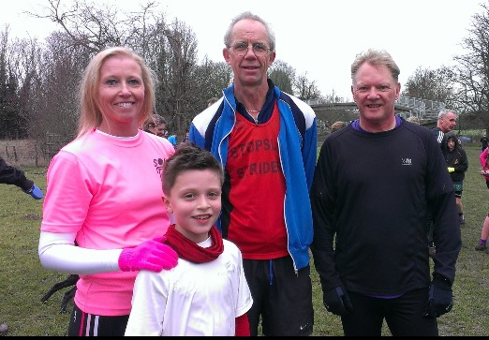
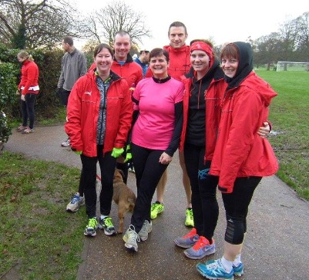

Our relatively new joiner, Robert Barnes ran the Hardmoors 30 in a time of 4:13:02. Great running Robert.
The usual Saturday Luton parkrun was attended by 20 Striders – Judy Reid achieved a parkrun pb of 31:51 and Hannah Crane ran her first ever parkrun – hope you enjoyed it Hannah and it’s the first of many !
The final race in the Three Counties Cross Country League on Sunday saw 39 Striders participate on an extremely muddy course at Sharnbrook. The Men’s Team included Mark Sains, Nathan Scott, Gez Fallon, Danny Kelly, Glynn Simmons, Ben Bodsworth, Pat Blessing, Martin Fallon, Andy Reid, Daniel Mann, Richard Hardy, Gary Fowler, Derek Christopher, Andy Durrant, Graham Busch, Jeff Dowsett, Dave Debnam, Stewart Read, Philip Davies, Dave Thompson, Tony Riley, Martin Smith, Lance Richardson, Finbar Willis, Simon Cain, Philip Abbitt and Kelvin Chadwick. The Ladies Team included Christine Lathwell, Linda Scanlan, Liz Rollinson, Dani Gibson, Lorraine Webb, Karen Ashby, Alison Davidson, Judy Reid, Valerie Dawson, Kim Caddy, Donna Wiggett and Hannah Fothergill.
At the end of 5 races, the Men’s Team finished 7th in the League, the Ladies finished 9th and the combined teams finished 8th overall ( oh, and we beat Dunstable !!! ).
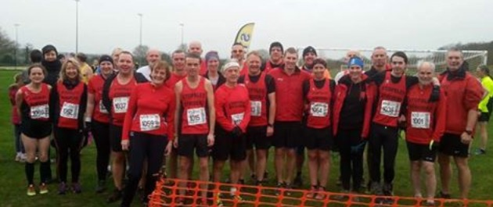
9th January
A rather busy Saturday for our Striders, including 13 crossing the Luton parkrun finish line. Not only did Hannah Fothergill achieve another pb of 25:06, but she was also 2nd lady home – well done Hannah, that’s fantastic running.
Pete Breslin travelled slightly further afield to Rushmere’s parkrun and Miriam Linforth took a trip up the M1 to join the parkrun in Northampton.
Amanda Rankin completed the Fowlmead Challenge – a 30.5mile Ultra in a time of 6:46:50 saying it was her first and last Ultra. A fantastic achievement Amanda.
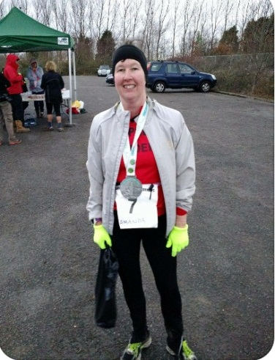
14 Striders including Christine Lathwell, Lorraine Webb, Mark Sains, Gez Fallon, Nathan Scott, Ben Bodsworth, Pat Blessing, Glynn Simmons, Andy Reid, Martin Fallon, Derek Christopher, Richard Hardy, Lance Richardson & Martin Smith took part in the Beds County Cross Country Championship - a difficult course at Shuttleworth College and brought back some silverware. The Vet 60 Men’s Team took 1st place, the Senior Men’s Team took 4th place. Christine Lathwell was V35 1st Female, Andy Reid was V60 2nd Man and Derek Christopher was V65 2nd Man.
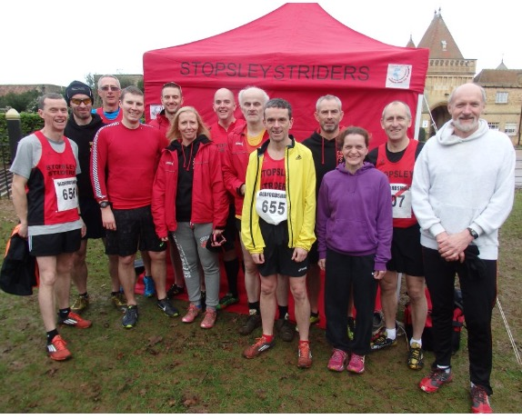

16th & 17th January
14 Striders braved the minus temperature and cold winter morning to cross the Luton parkrun finish line. Both Alison Sugars & Siobhan Jenkins obtained parkrun pbs (23:54 & 28:51) respectively – well done ladies !!
Ben Bodsworth took a little trip up the A6 to Bedford and smashed his target, crossing the finish in 19:50 and pocketing a nice little pb in the process, taking 24 seconds off – well done Ben. Looks like trackwork is paying off as you are getting better & better as each week passes.
Not one to let the cold and snowy morning deter her, Lorraine Webb snuck down ( there’s a pattern forming here Lorraine !! ) to Kingston-Upon-Thames to take part in the Bushy Park 10k and took 3mins and 9seconds off her previous pb, finishing in 50:01 – you must work on your sprint finish ready for the next one and lose that odd second !


23rd & 24th January
15 Striders turned out for the parkrun with Pat Blessing, not only leading the Striders home but also gaining a pb of 20:19 in the process and David Brown also got a pb of 26:10 – way to go guys !!
Graham Busch travelled to Bedford and finished their parkrun in a pb time of 23:45.
A brilliant turnout on Sunday saw 14 Striders running the Fred Hughes 10mile undulating course. Ben Bodsworth was the first Strider home collecting another PB of 1:12:42. He was followed by Liz Rollinson (1:14:02), Sarah Cashin (1:16:00), Dani Gibson (1:21:56 PB), Andy Durrant (1:25:40), Willie Ellingham (1:27:06), Tom Willis (1:27:34), Nick Crane (1:27:50), Lorraine Webb (1:27:51 PB), Tony Riley (1:31:00), Hannah Fothergill (1:31:42 PB), Valerie Dawson (1:39:06), Terry Willis (1:40:23) and Zena Ellis (1:41:45).

John Chapman participated in the Folksworth 15 and completed the undulating course on country roads in a time of 1:48:04.

30th & 31st January
15 Striders ran the Luton parkrun on a very windy Saturday morning. 3 PBs were achieved this week – Dani Gibson (22:13), Hannah Fothergill (24:49) and Kim Caddy (27:18) – well done ladies !
Heading down to take part in the Southern Cross Country Championships were: Christine Lathwell, Gez Fallon, Glynn Simmons, Martin Fallon, Paul Keech, Pat Blessing, Derek Christopher. All ran extremely well and did their Club proud as that was no easy course – especially in the very windy conditions that were against us today. Paul & I hope you had a few well deserved glasses of beer !

8 Strider of the Month

Strider of the Month was awarded to:
- Ben Bodsworth and Hannah Fothergill

9 Suggestions Box

Bring back the Luton Marathon? This is not possible particularly in its past form. It was suggested that the Luton Half Marathon could offer a double half marathon on their course.

Suggestion to Get Stuart Harries a meal out as recognition for his past work. This was not accepted.

Change the name of Stopsley Striders J.C.? Not accepted.

Look into the possibility of Km markers for the Park Run? Not accepted.

Can we put Signpost on the club vests? Not accepted, but could be considered if a special vest was made, if we go ahead with organising a new special race.

Change the colour awards. Not accepted.

10 A.O.B.

Leaflets?
DD asked for someone else to take on the club kit management. It was agreed that the Captains, Paul and Lorraine would jointly take it on

Club Membership renewal is due on the 1st April so it was agreed that AR & CG would work together to collect renewals from the 1st March. AR will provide a form to record the entrys.

Discussion re the next beginners course. We will advertise from the start of March with the course starting on May 5th.

A Coaches meeting needs to be arranged, and we need to encourage runners to do stretches before and after running.

Miriam advised the committee that she is organising a Half Marathon on Sept 12th for the Canal Trust. She will be looking for support with Marshalls, Runners etc.

NS will continue with organising a club race to take place in August or September this year.

After discussion it was agreed that new members would receive a free club vest to reduce the initial cost of joining from April 2016.

Meeting closed.

Next Meeting to be held on the 7th March 2016

